|  |  |
| --- | --- |
| **Name :** | **Date :** |
| **Roll No :** | **Signature :** |
| **Class : SE CMPN - A** | **Grade :** |
| **Batch :** |  |
| **Experiment No: 3** |  |

**Title:** Universal Shift Register and Bi- Directional Shift Registers

**Estimated time to complete this experiment:** 2 hours

**Objective:**

1.Understanding behaviour of Universal shift register and Bi-Directional shift resistor from module designed by the student as part of the experiment .

2.Understanding the concept of shift registers by implementing them with the help of D- Flip-Flops

**Books/ Journals/ Websites referred:**

Books:

Digital Logic and Computer Design - M. Morris Mano. Pearson Education - Prentice Hall.

Digital Principles Foundation of Circuit Design and Application - Arun Kumar Singh. New Age Publishers.

The Art of Electronics - Paul Horowitz and Winfield Hill (1989). Cambridge University Press

Modern Dictionary of Electronics - Rudolf F. Graf (1999). Newnes

Web Sites:

* https://en.wikipedia.org/wiki/Shift_register
* [NPTEL (e-learning courses from IITs and IISC)](http://nptel.iitm.ac.in/courses.php?disciplineId=106)

**Requirements:** Virtual simulator.

* **Components :-**

**Universal Shift Register**

* 4 D Flip-Flops.
* Wires to connect.
* LED display to obtain the output.
* 16 and gates and 8 or gates.
* 1 Clock Input.

**Bi – Directional Shift Register**

* 4 D Flip-Flops.
* Wires to connect.
* LED display to obtain the output.
* 8 and gates and 4 or gates.
* 1 Clock Input.

**Circuit Diagram:**

**Universal Shift Register**

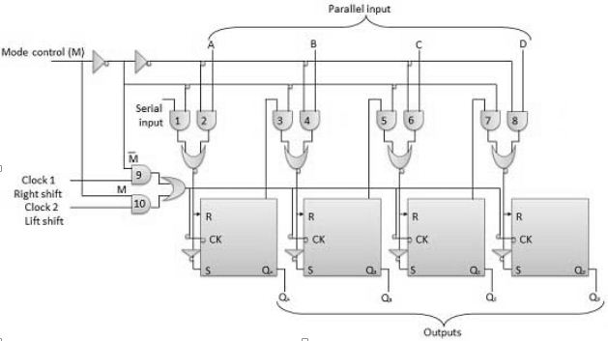

**Bi- Directional shift register**

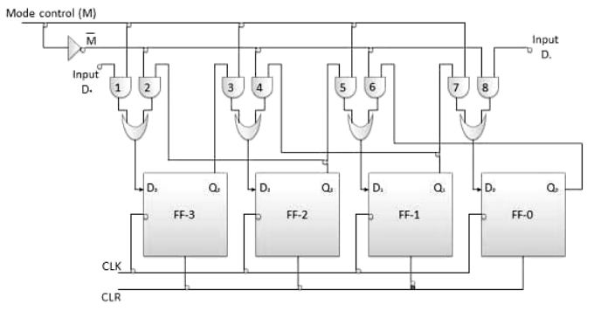

**Procedure:**

1. Start the simulator as directed.
2. To design the circuits we need 4 D Flip-Flops, 8 AND gates,4 OR gates, 8 Bit displays(to see the output from each of the Flip-Flops input and output), a clock input, wires.
3. The pin configuration of a component is shown whenever the mouse is hovered on any canned component of the palette. Pin numbering starts from 1 and from the bottom left corner(indicating with the circle) and increases anticlockwise.
4. For D Flip-Flop input is in pin-8 for clock input, preset and clear are set to 1, output from the AND and OR gate combination is given to pin 5 of the flip-flop.
5. Click on the D flip-flop component with preset and clear (in the sequential circuits drawer in the pallet) and then click on the position of the editor window where you want to add the component(no drag and drop, simple click will serve the purpose), likewise add 2 more flip-flops(from the sequential circuits drawer in the pallet), and all the AND and OR gates required(from Logic Gates drawer in the pallete), 8 bit Displays, 1 clock input(from Display and Input drawer of the pallet, if it is not seen scroll down in the drawer).
6. To connect any two components select the Connection menu of Palette, and then click on the Source terminal and click on the target terminal. According to the circuit diagram connect all the components. Start the clock input using the input provided in the top palette the output from each flip-flop is taken into a bit display which displays the bit output.

**Conclusion:** Flip-Flops can store a single bit of binary data. But if we need to store multiple bits of data , we need multiple Flip-Flops. As a single Flip-Flop is required for one bit on data n Flip-Flops are required for n bits of data. Hence Registers are required.

A Bi-Directional shift register can shift the data left or right so as to perform multiplication or division.

A Universal shift register can also be used to shift the data left or right but can also load the data in parallel as well.

**Real Life Application:**

Data Manipulation.

Data Transfer.

Temporary Data Storage.

As Counters.

**Post Lab Questions:**

Q. Why are shift registers considered to be basic memory devices?

Q. What is the difference between serial and parallel transfer?

Q. The bit sequence 0010 is serially entered (right-most bit first) into a 4-bit parallel out shift register that is initially clear. What are the Q outputs after two clock pulses?

Q. A bidirectional 4-bit shift register is storing the nibble 1101. Its RIGHT/LEFT' input is HIGH. The nibble 1011 is waiting to be entered on the serial data-input line. After three clock pulses, what the shift register will be storing?